Midterm Assignment – Monika Kostovska

Mid-Term Task

Part I   
1. Host a static website on Blob Storage: build and deploy a static Hello World website to Azure Storage.

2. Verify that the default web page has the Hello World! page.

3. Provide the steps and results

First we create new storage account

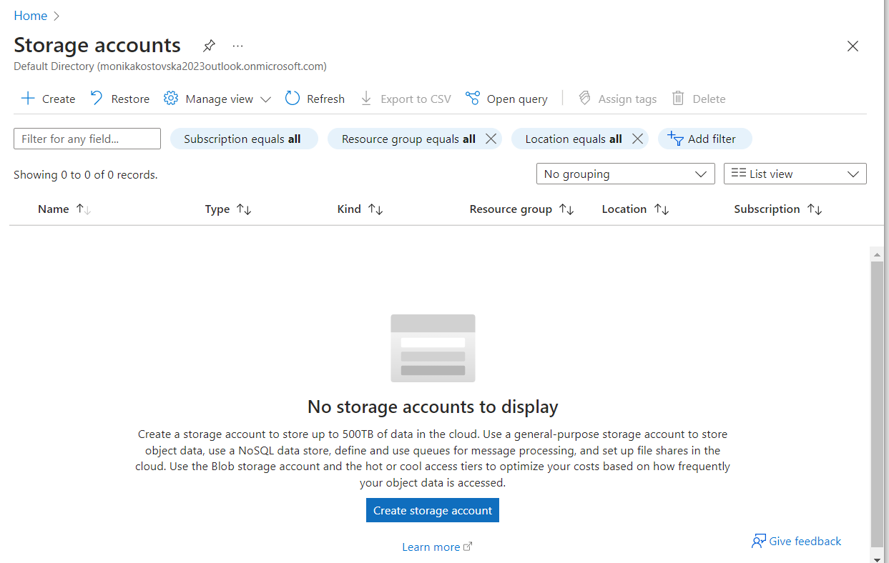

We type a name for the resource group (RG-static-website)

and name for the storage account (monikaweb)

leave everything else as default

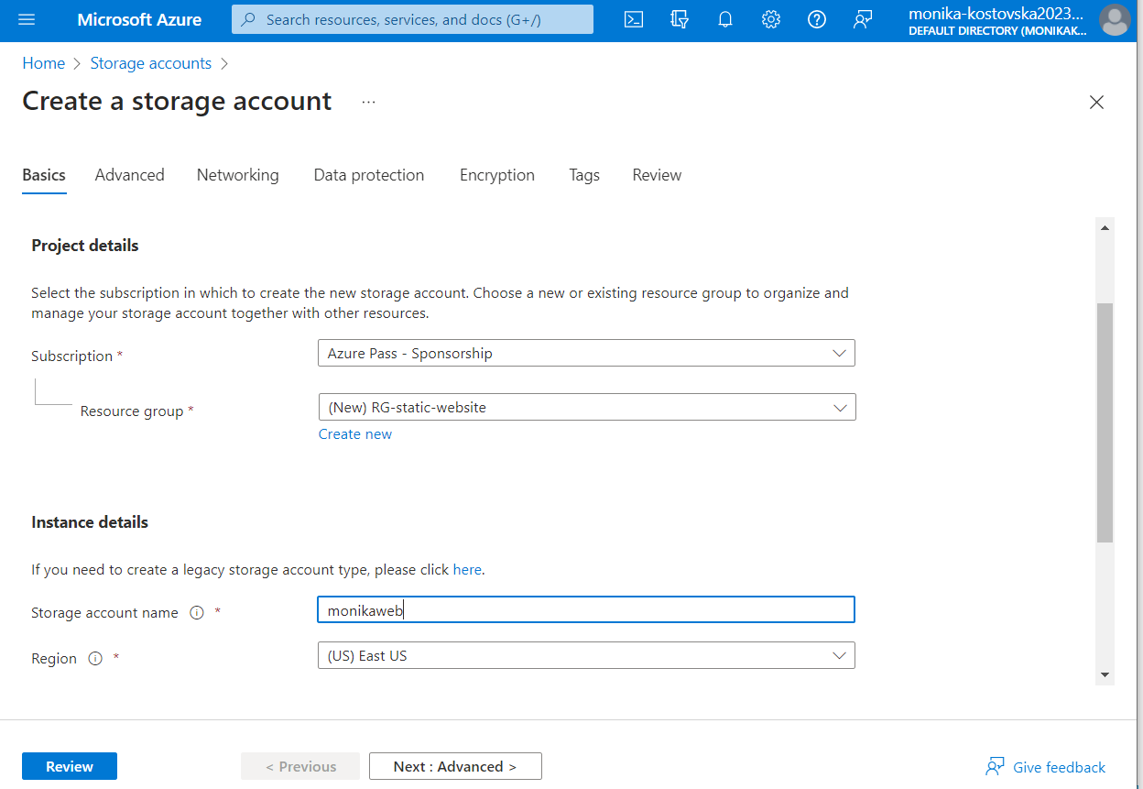

review and create

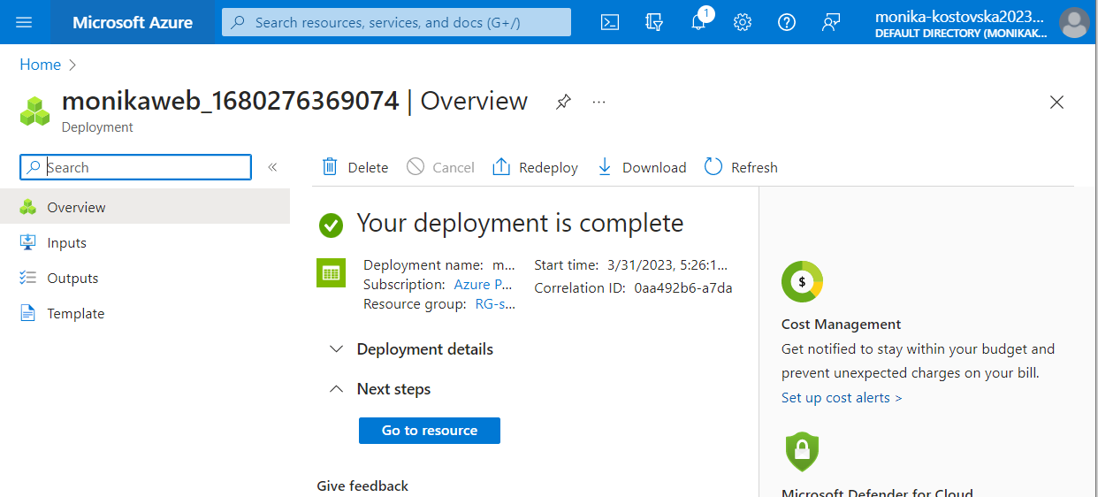

Next, we go to resource and open static website > enable  
I created a file with Hello World by the name index.html and I am typing the name in index doc

And save

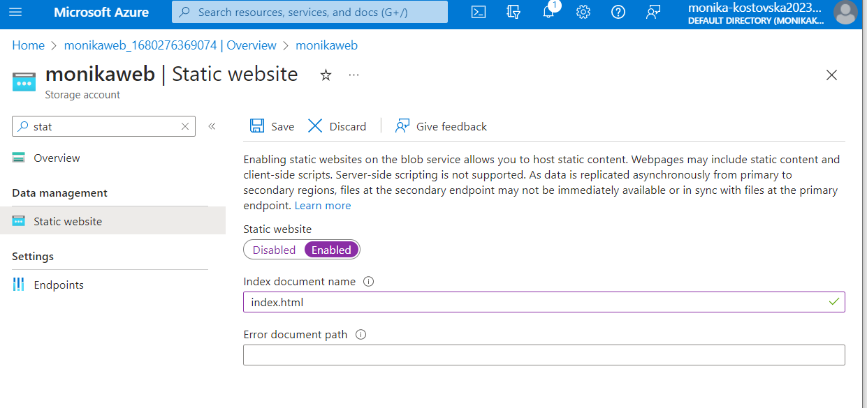

We open containers > $web

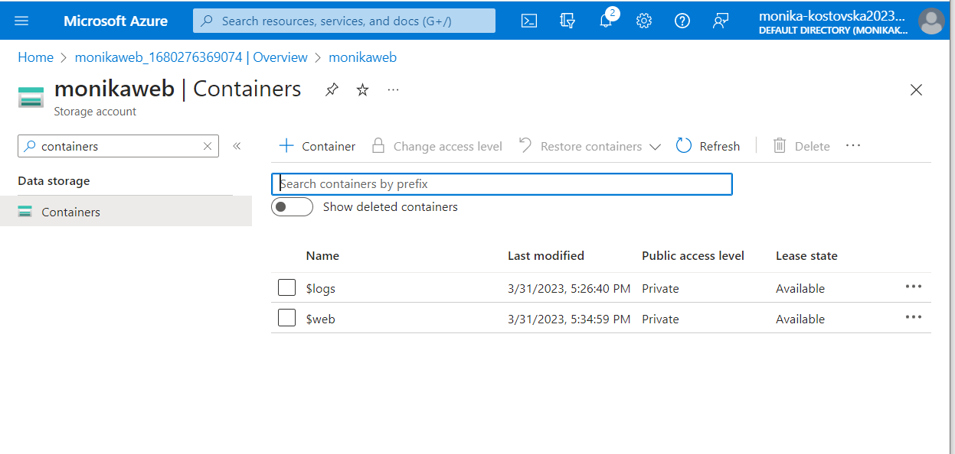

Upload blob and attach the html file 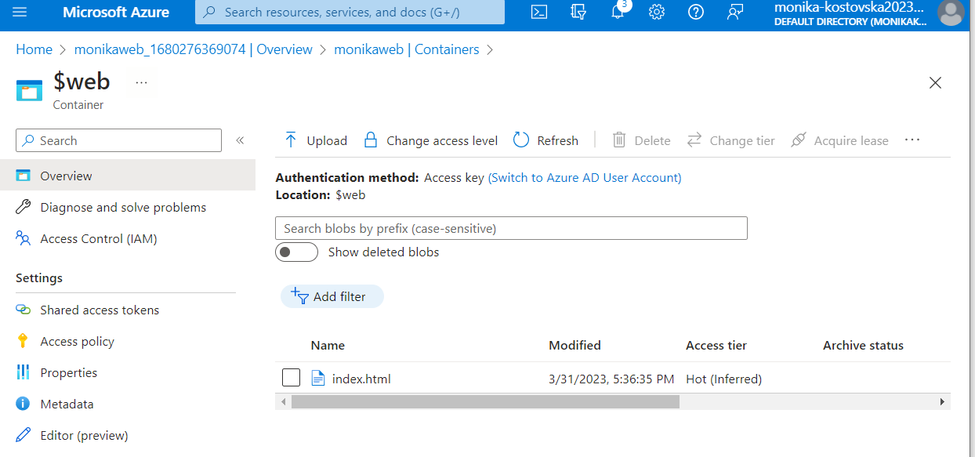

From storage acc > static web we copy the primary end point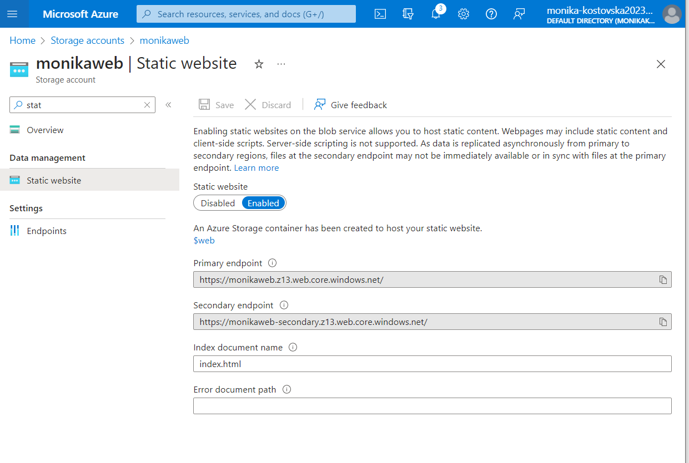

open new tab and Hello World from the html file will apear

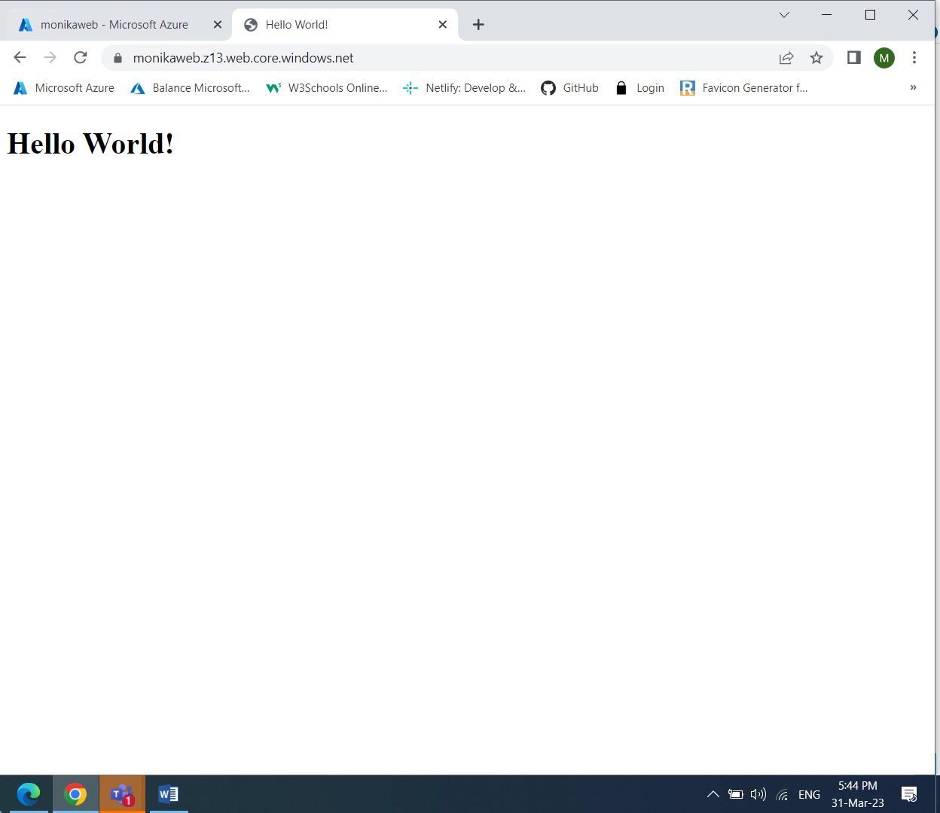

Part II

In this exercise we will setup a Linux based web server and will

deploy a web page on it.

1. Create a Virtual Network where you will deploy your Linux Based

Web Server.

2. Modify the network security group for your virtual machine that will

allow you to remotely manage your machine only from your local

machine and nowhere else.

3. Create a Linux Virtual Machine that will be your Web Server which is

publicly available for web publishing (not SSL) only from your

machine and nowhere else.

4. Connect to the VM.

5. Install Apache Web Server.

6. Deploy the “Hello World” web page.

7. Provide Testing from your cellphone.

8. Provide the steps and results.

Start by creating a virtual machine and virtual network 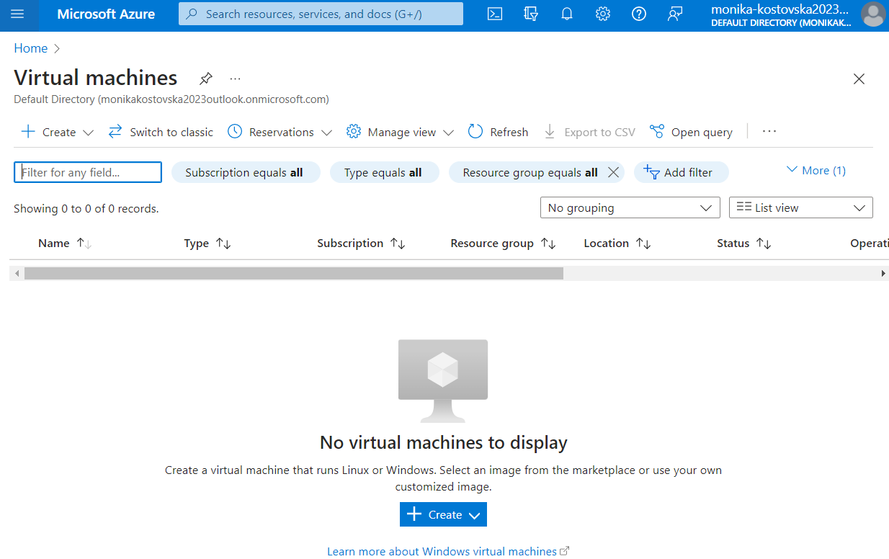

Set up resource group and name for the VM on the first step in basics  
chose Ubuntu and set up a user and password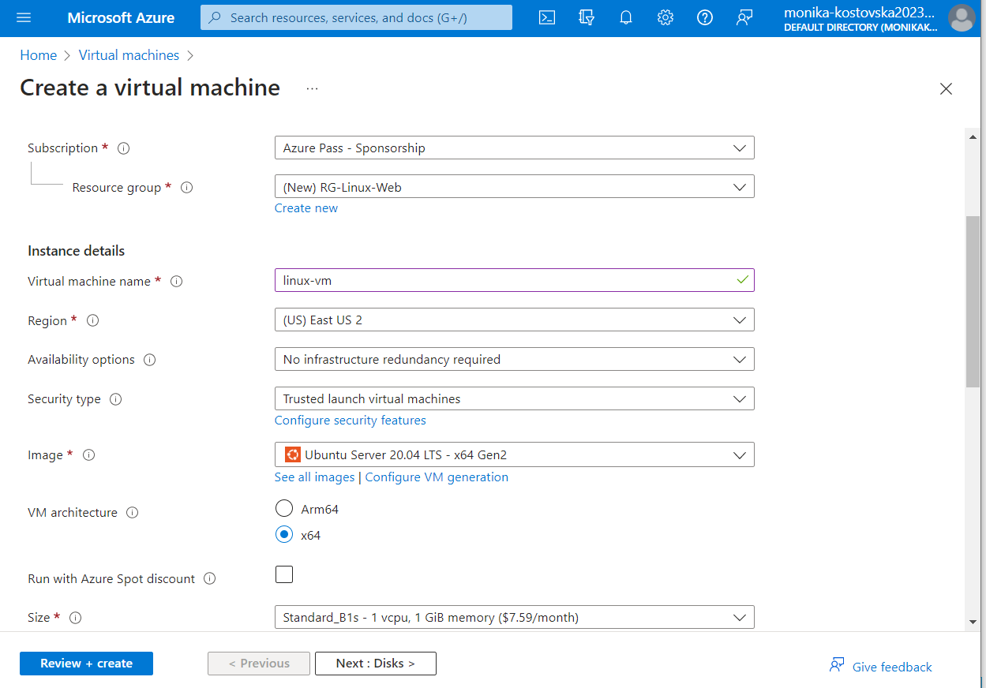

Enable ports HTTP 80 and SSH 22 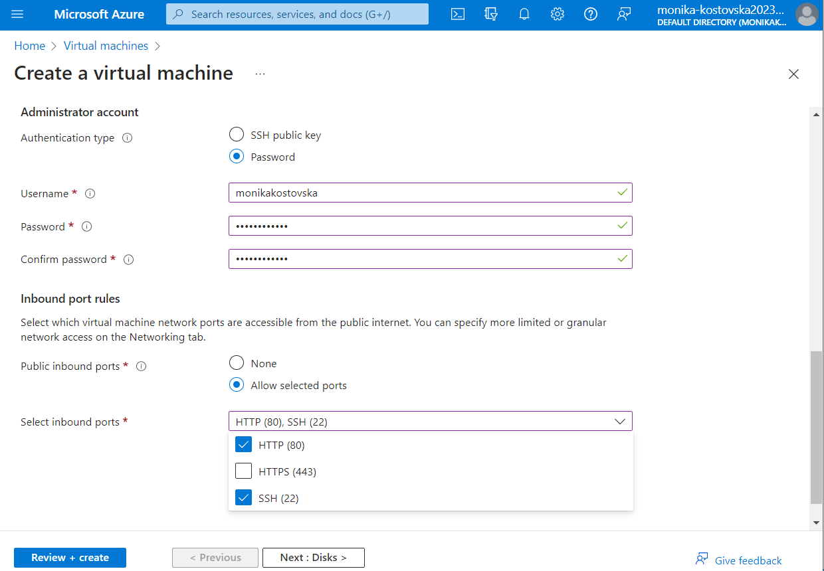

Create the VM

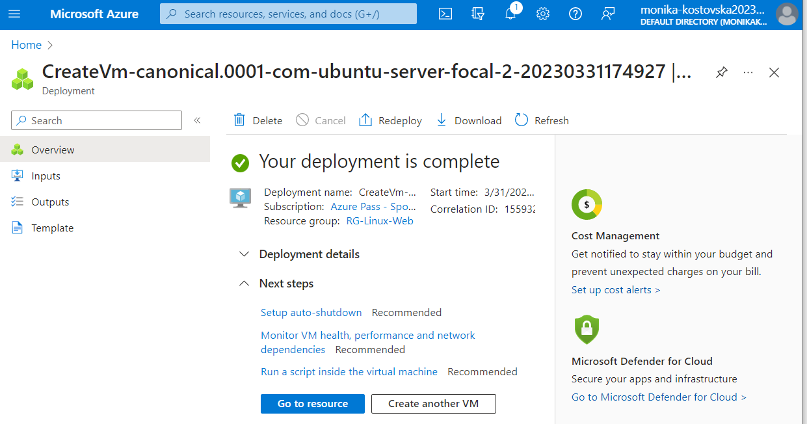

the virtual network is created as well  
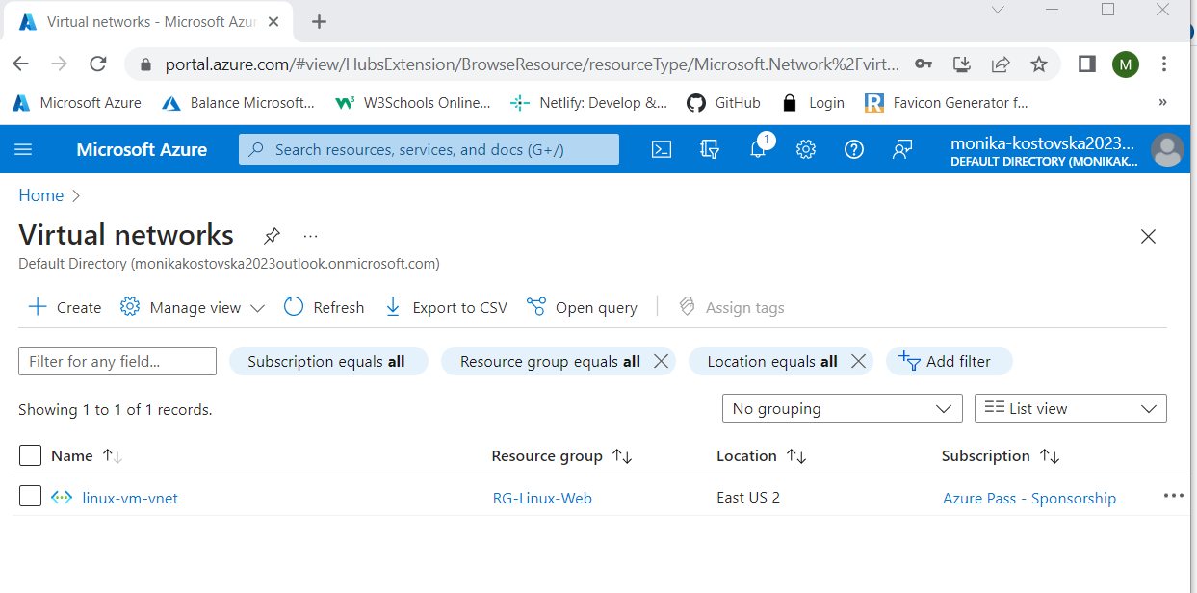

Next, Go back to the VM and select networking  
Edit the network security group - SSH and select my IP address only   
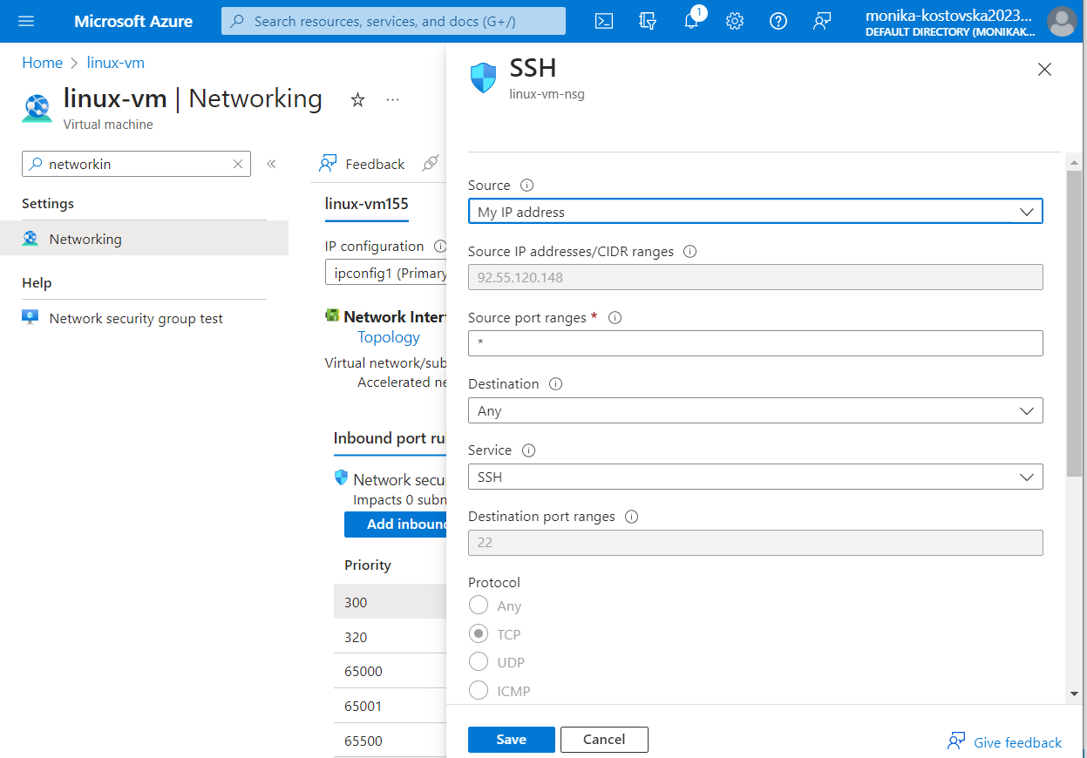

With this we are modifying the network security group from the VM that will allow to remotely manage only from the local machine

Connect the VM  
Run ssh username@IP address  
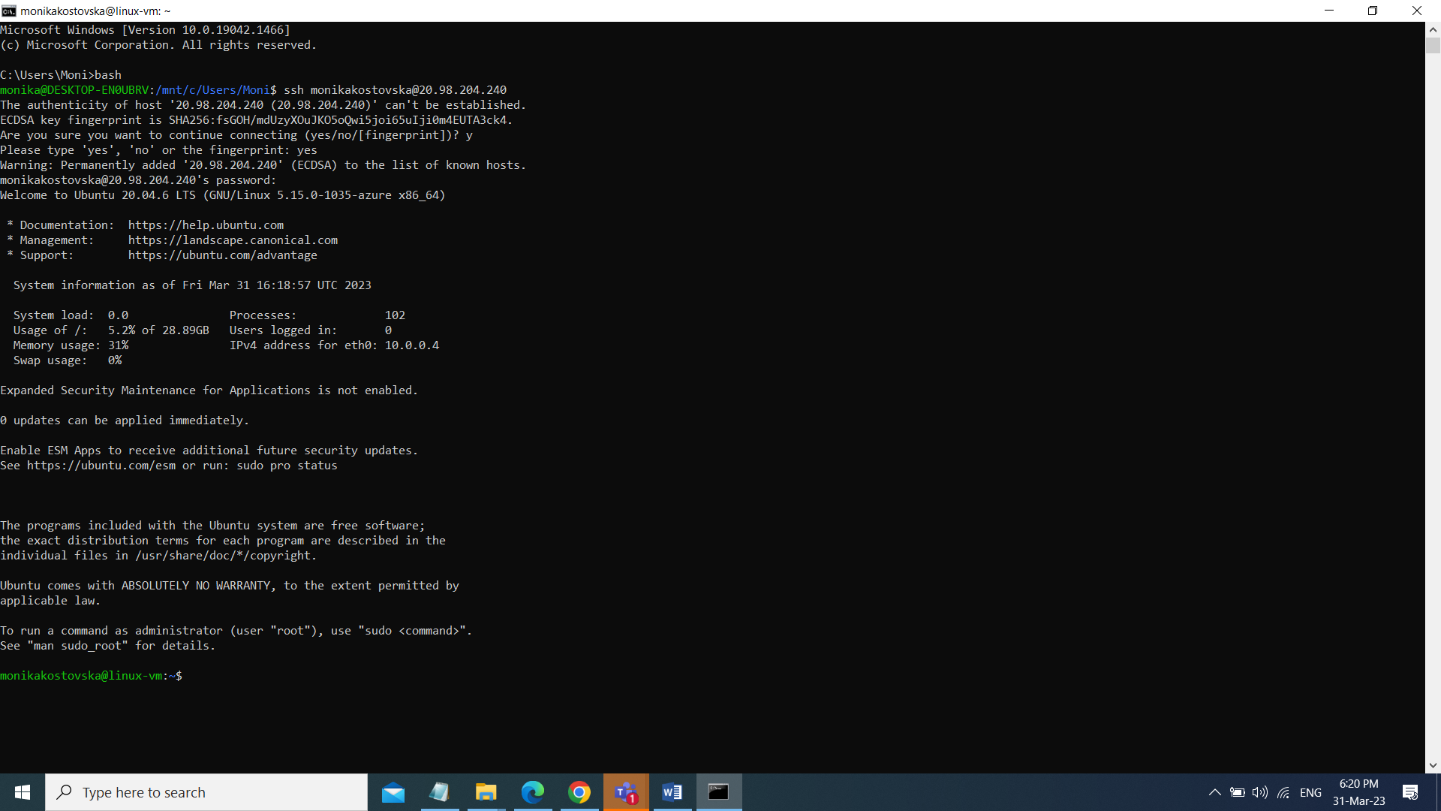

Install apache web server   
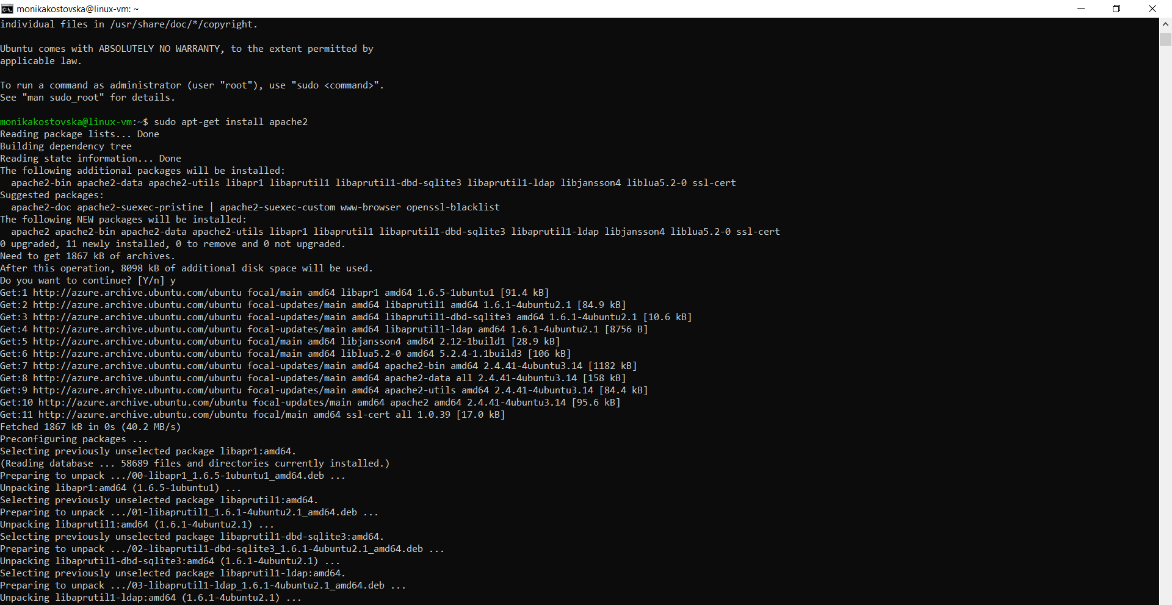

Enter root directory   
Apache files live in /var/www/html/   
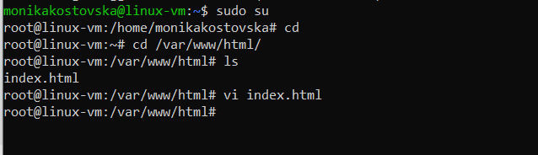  
as we list we can see existing index.html fil that we can edit

Open the html file and paste the html code that was provided for Hello world

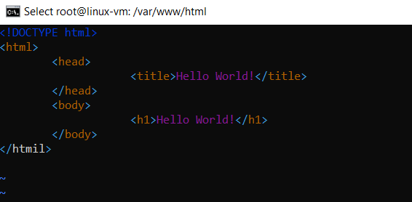

After this is saved we can open a new tab and check 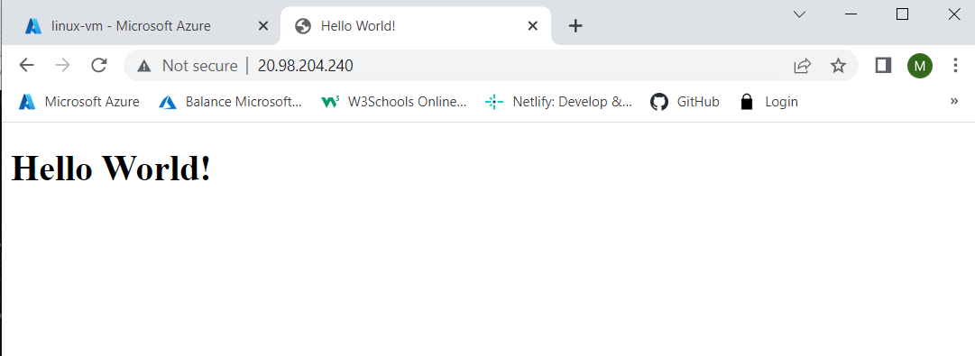

And test from the cellphone as well

